**Project-2 Title: Stock-ETL**

Team members:

Jacob

Luciano

Mano

Synopsis:

Extracting the stock data of 500 US companies with 20 years of data by different sectors. We are joining the data with the exchange rate to display the results in one another currency.

Analyze the stock data for:

1. Highest trading companies by year
2. Highest trading company by volume
3. Highest change in value
4. Lowest change in value
5. Average price by company
6. Address all the above in a foreign currency

<https://github.com/JacobSpear/ETL-Stocks> (Reository)

<https://www.alphavantage.co/documentation/#> (Stock data & Exchange rate)

<https://datahub.io/core/s-and-p-500-companies#resource-constituents> (S&P data for Tickers)

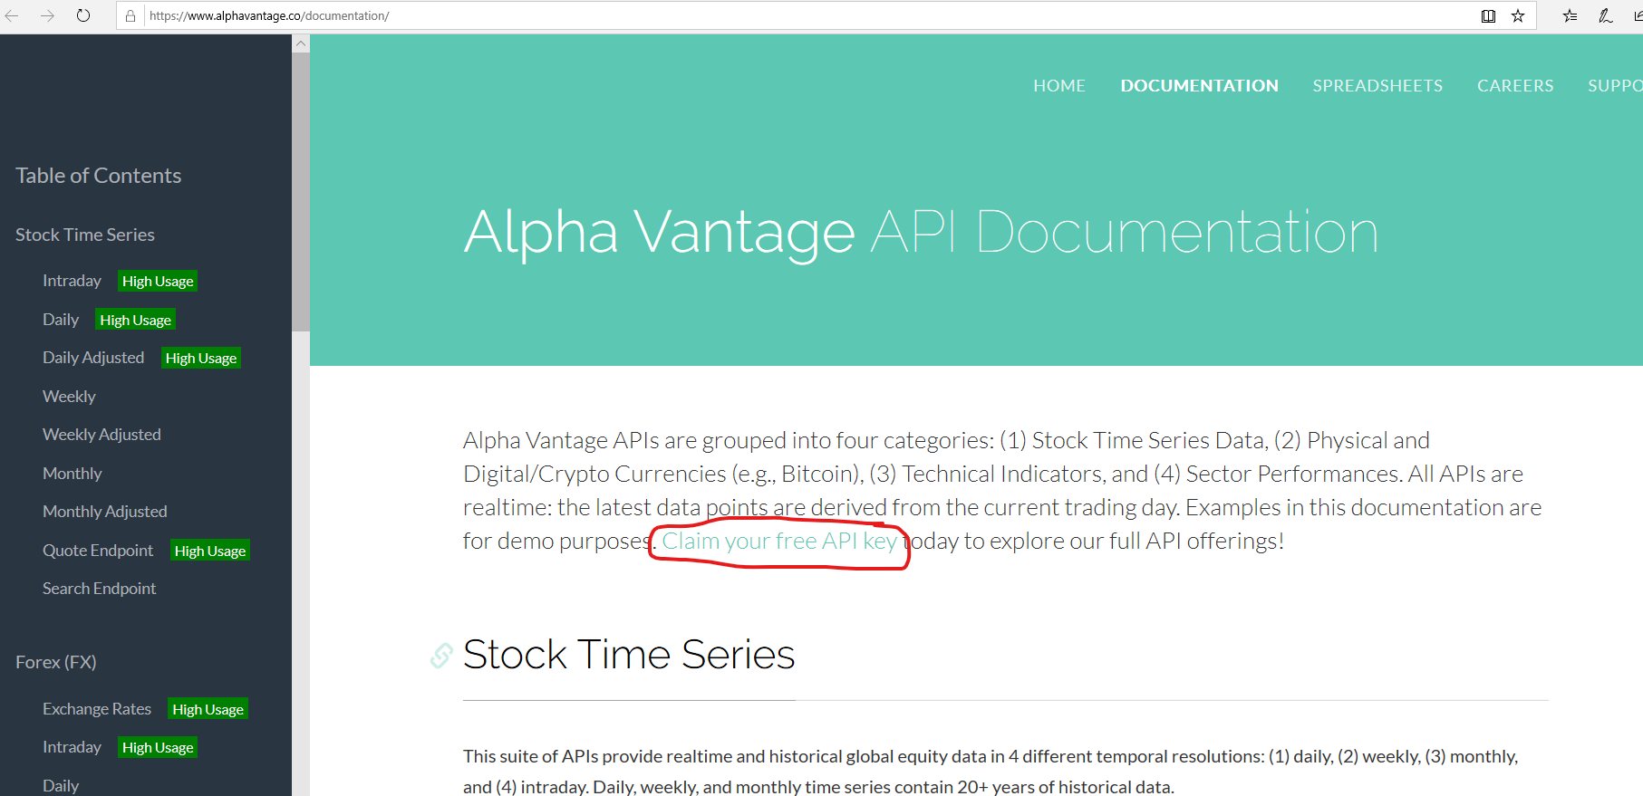

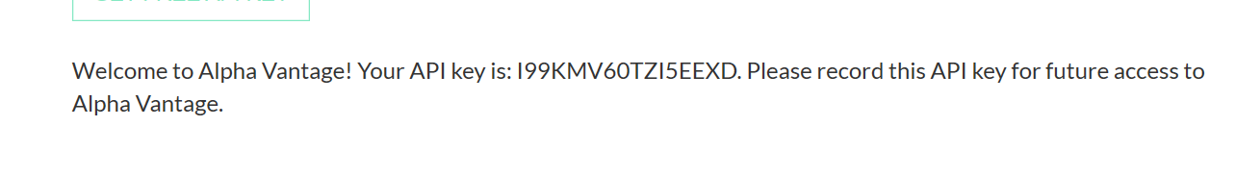

N2YUAO8BI7OCP2HB

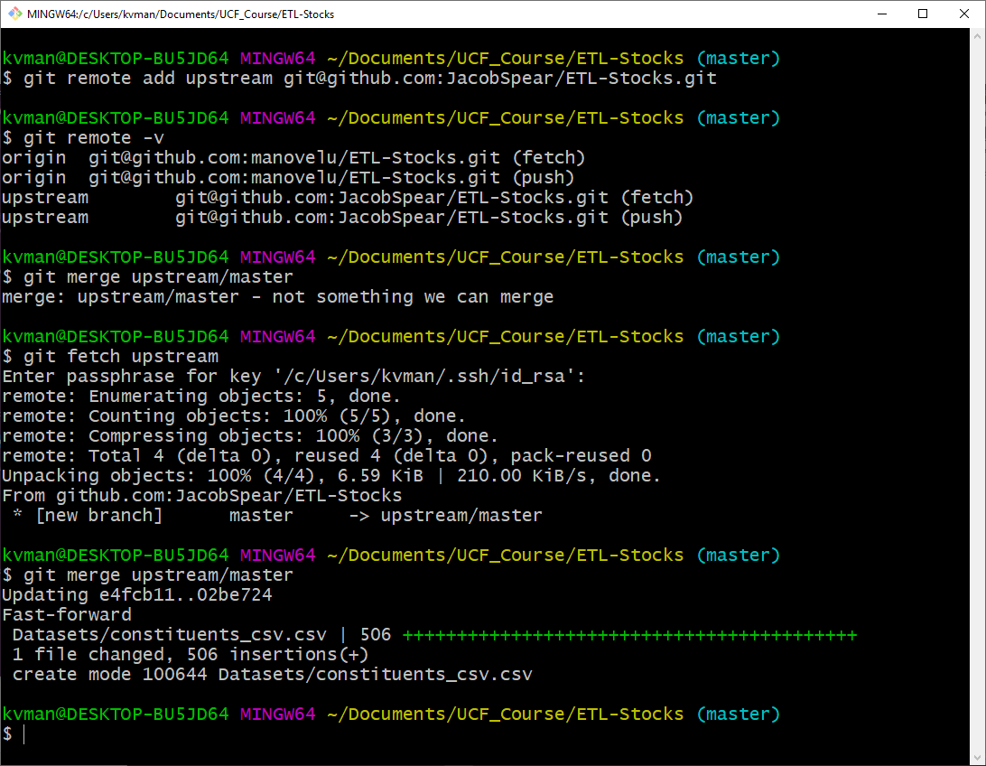

kvman@DESKTOP-BU5JD64 MINGW64 ~/Documents/UCF_Course/ETL-Stocks (master)

$ git remote add upstream git@github.com:JacobSpear/ETL-Stocks.git

kvman@DESKTOP-BU5JD64 MINGW64 ~/Documents/UCF_Course/ETL-Stocks (master)

$ git remote -v

origin git@github.com:manovelu/ETL-Stocks.git (fetch)

origin git@github.com:manovelu/ETL-Stocks.git (push)

upstream git@github.com:JacobSpear/ETL-Stocks.git (fetch)

upstream git@github.com:JacobSpear/ETL-Stocks.git (push)

kvman@DESKTOP-BU5JD64 MINGW64 ~/Documents/UCF_Course/ETL-Stocks (master)

$ git merge upstream/master

merge: upstream/master - not something we can merge

kvman@DESKTOP-BU5JD64 MINGW64 ~/Documents/UCF_Course/ETL-Stocks (master)

$ git fetch upstream

Enter passphrase for key '/c/Users/kvman/.ssh/id_rsa':

remote: Enumerating objects: 5, done.

remote: Counting objects: 100% (5/5), done.

remote: Compressing objects: 100% (3/3), done.

remote: Total 4 (delta 0), reused 4 (delta 0), pack-reused 0

Unpacking objects: 100% (4/4), 6.59 KiB | 210.00 KiB/s, done.

From github.com:JacobSpear/ETL-Stocks

* [new branch] master -> upstream/master

kvman@DESKTOP-BU5JD64 MINGW64 ~/Documents/UCF_Course/ETL-Stocks (master)

$ git merge upstream/master

Updating e4fcb11..02be724

Fast-forward

Datasets/constituents_csv.csv | 506 ++++++++++++++++++++++++++++++++++++++++++

1 file changed, 506 insertions(+)

create mode 100644 Datasets/constituents_csv.csv

kvman@DESKTOP-BU5JD64 MINGW64 ~/Documents/UCF_Course/ETL-Stocks (master)